1. Go to SE11
2. Select Data Type. Enter the name of table type as zxxxxxxSCARRTAB

where xxxxxx is your empcode.

104329 in this example.

1. Select Table Type.
2. Select Line Type. Enter SCARR. This is a DB table present in DDIC.
3. Save and Activate.

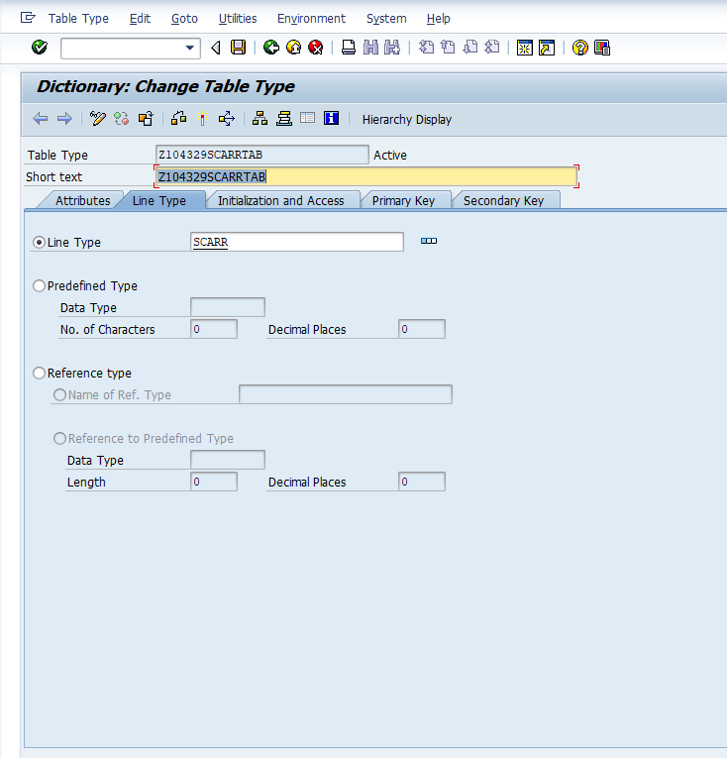

REPORT z.  
*"DATA ITSCARR TYPE TABLE OF SCARR.*  
DATA ITSCARR TYPE Z104329SCARRTAB.  
DATA WA LIKE LINE OF ITSCARR.  
  
SELECT MANDT CARRID CARRNAME CURRCODE URL   
  FROM SCARR INTO TABLE ITSCARR.  
    
LOOP AT ITSCARR INTO WA.  
  WRITE / WA-CARRID.  
  WRITE WA-CARRNAME.  
  WRITE WA-CURRCODE.  
  WRITE WA-URL.    
ENDLOOP.      
    
  